Write a PHP Code to perform Following Programs:
i) Connect PHP to a MySQL database and perform basic CRUD operations (Create,
Read, Update, Delete).
ii) Use prepared statements and parameterized queries in PHP to prevent SQL injection.
iii)Write PHP scripts to interact with MySQL databases, performing queries and
displaying results on a webpage
==============================================================================
COMMAND:
FOLDER STRUCTURE:
htdocs/
├PRAC13
├── db.php
├── index.php
└── edit.php

color: red;
font-size: 14px;
DB.PHP
<?php
$servername = "localhost";
$username = "root";
$password = "";
$database = "college_db";

// Create Connection
$conn = new mysqli($servername, $username, $password, $database);

// Check Connection
if ($conn->connect_error) {
die("Connection Failed: " . $conn->connect_error);
}
?>

EDIT.PHP
<?php
include "db.php";

$id = $_GET['id'];
$stmt = $conn->prepare("SELECT * FROM students WHERE id=?");
$stmt->bind_param("i", $id);
$stmt->execute();
$result = $stmt->get_result();
$row = $result->fetch_assoc();
?>

<!DOCTYPE html>
<html>
<head>
<title>Edit Student</title>
</head>
<body>

<h2>Edit Student</h2>

<form method="POST" action="index.php">
<input type="hidden" name="id" value="<?php echo $row['id']; ?>">

Name: <input type="text" name="name" value="<?php echo $row['name']; ?>" required><br><br>
Email: <input type="email" name="email" value="<?php echo $row['email']; ?>" required><br><br>
Course: <input type="text" name="course" value="<?php echo $row['course']; ?>" required><br><br>

<button type="submit" name="update">Update Student</button>
</form>

</body>
</html>

INDEX.PHP
<?php
include "db.php";

// INSERT (CREATE) - Using Prepared Statement
if(isset($_POST['add'])) {
$name = $_POST['name'];
$email = $_POST['email'];
$course = $_POST['course'];

$stmt = $conn->prepare("INSERT INTO students (name, email, course) VALUES (?, ?, ?)");
$stmt->bind_param("sss", $name, $email, $course);
$stmt->execute();
$stmt->close();
header("Location: index.php");
}

// DELETE - Using Prepared Statement
if(isset($_GET['delete'])) {
$id = $_GET['delete'];

$stmt = $conn->prepare("DELETE FROM students WHERE id=?");
$stmt->bind_param("i", $id);
$stmt->execute();
$stmt->close();
header("Location: index.php");
}

// UPDATE - Using Prepared Statement
if(isset($_POST['update'])) {
$id = $_POST['id'];
$name = $_POST['name'];
$email = $_POST['email'];
$course = $_POST['course'];

$stmt = $conn->prepare("UPDATE students SET name=?, email=?, course=? WHERE id=?");
$stmt->bind_param("sssi", $name, $email, $course, $id);
$stmt->execute();
$stmt->close();
header("Location: index.php");
}
?>

<!DOCTYPE html>
<html>
<head>
<title>PHP MySQL CRUD with Prepared Statements</title>
<style>
body { font-family: Arial; }
table { border-collapse: collapse; width: 80%; }
th, td { padding: 10px; border: 1px solid black; }
form { margin-bottom: 20px; }
</style>
</head>
<body>

<h2>Student Management System (CRUD)</h2>

<!-- CREATE FORM -->
<form method="POST">
Name: <input type="text" name="name" required>
Email: <input type="email" name="email" required>
Course: <input type="text" name="course" required>
<button type="submit" name="add">Add Student</button>
</form>

<?php
// FETCH DATA (READ) - Query + Display on Webpage
$result = $conn->query("SELECT * FROM students");
?>

<table>
<tr>
<th>ID</th>
<th>Name</th>
<th>Email</th>
<th>Course</th>
<th>Actions</th>
</tr>

<?php while($row = $result->fetch_assoc()) { ?>
<tr>
<td><?php echo $row['id']; ?></td>
<td><?php echo $row['name']; ?></td>
<td><?php echo $row['email']; ?></td>
<td><?php echo $row['course']; ?></td>
<td>
<a href="edit.php?id=<?php echo $row['id']; ?>">Edit</a> |
<a href="index.php?delete=<?php echo $row['id']; ?>"
onclick="return confirm('Are you sure?')">Delete</a>
</td>
</tr>
<?php } ?>
</table>

</body>
</html>

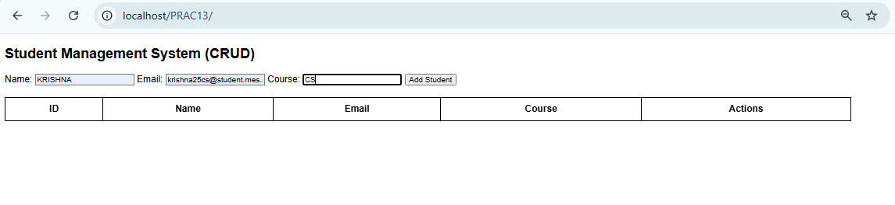
OUTPUT:
